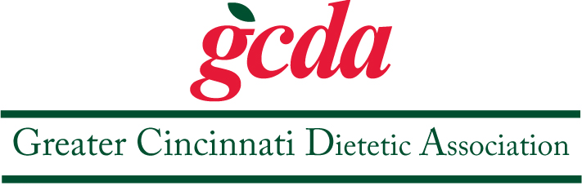

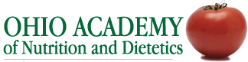
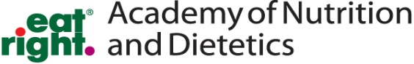

*Journal Club East*
Artificial Sweeteners
Date/Time: Tuesday October 24, 2016. 5:30 pm – 7:00 pm
Location: Hyde Park Public Library / Provides 2 CEU’s, Target audience: RD’s & DTR’s
RSVP by October 17, 2016 to Morgan Cheung @ MorganLCheung@gmail.com

Learning Objectives: at the end of the review participants will be able to …
- Apply and integrate evidence-based research and literature in nutrition recommendations
- Discuss the effects or artificial sweeteners on obesity and health status
- Describe the history behind the artificial sweetener controversy
- Discuss the current trends and hype surrounding artificial sweeteners

If you would like to attend, please select an article. Once you have selected an article notify the coordinator of your selection and a PDF of the article will be provided to you.
Articles:
- Artificial Sweetener as a Historical Window to Culturally Situated Health
- Artificially Sweetened Beverages and the Response to the Global Obesity Crisis
- Aspartame administered in Feed Beginning Prenatally Through Life Span Induces Cancer of the Liver and Lung in Mice
- Can Children Discriminate Sugar Sweetened from Nonnutritively Sweetened Beverages and How do they Like Them?
- Chronic Consumption of Artificial Sweetener in packets or Tablets and Type 2 Diabetes Risk
- Chronic Low-Calorie Sweetener Use and Risk of Abdominal Obesity Among Older Adults
- Diet Soda Intake is Associated with Long-Term Increases in Waist Circumference in a Bioethnic Cohort of Older Adults
- Effects of the Non-Nutritive Sweeteners on Glucose Metabolism and Appetite Regulating Hormones
- First Experimental Demonstration of the Multipotential Carcinogenic Effects of Aspartame Administered in the Feed to Rats
- Integration of Sweet Taste and Metabolism Determines Carbohydrate Reward
- Nonnutritive Sweeteners and Cardiometabolic Health
- Socio-demographic Correlates and Trends in low-calorie Sweetener Use Amon Adults in the US from 1999-2008
- Soft Drinks Aspartame and the Risk of Cancer and Cardiovascular Disease
- Stevia a Bio-Sweetener: A Review
- Sugar Alcohols: Their Role in the Modern World of Sweeteners
One of our GCDA member benefits are our 2 Journal Clubs, one on the east side and one on the west side. The group picks the topics – the coordinator selects 10 or so articles on that topic. Members who would like to attend should contact the coordinator and request an article. Each member should review the article and presents a summary of the article. After each member presents the group will discuss the topic. It is a small group, nice discussion. Please plan to join us.
Journal Club East Coordinator: Morgan Cheung, RDN, LD MorganLCheung@gmail.com

